

Configure Authentication for an Azure Web App

Understand the scenario

You are an Azure® administrator. You need to create an Azure web app that uses authentication. First, you will create an Azure web app. Next, you will deploy a sample web app, and then you will test the web app. Finally, you will enable authentication by using Azure Active Directory®.

Understand your environment

You will be using an Azure resource group named corp-datalod26430177.

# **Create an Azure web app**

* Sign in to the Azure portal
* Create an Azure Web App by using the values in the following table. For any property that is not specified, use the default value.

| **Property** | **Value** |
| --- | --- |
| Resource Group | **corp-datalod26430177** |
| Name | wa26430177 |
| Publish | **Code** |
| Runtime stack | **ASP.NET V4.8** or the latest version that is not preview or early access |
| Region | **East US** |
| Windows Plan (East US) | AppPlan1 |
| Sku and size | **Standard S1** |
| Enable Application Insights | **No** |

* Expand this hint for guidance on creating an Azure web app.
  + On the Azure portal home page, select **Create a resource** to open the Azure Marketplace.
  + In the Azure Marketplace, search for and select Web App, and then select **Create**.

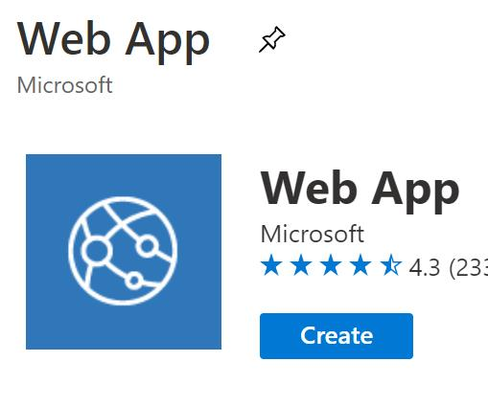

* + On the Create Web App blade, on the Basics page, in Resource Group, select **corp-datalod26430177**, and then in Name, enter wa26430177.
  + In Publish, ensure that **Code** is selected, in Runtime stack, select **ASP.NET V4.8** (or the latest version that is not in preview or early access), and then in Region, select **East US**.
  + In Windows Plan (East US), select **Create new**, in Name, enter AppPlan1, and then select **OK**.
  + In Sku and size, select **Change size**.
  + On the Spec picker blade, ensure that the **Production** tile is selected, in Recommended pricing tiers, select the **S1** tile, and then select **Apply**.

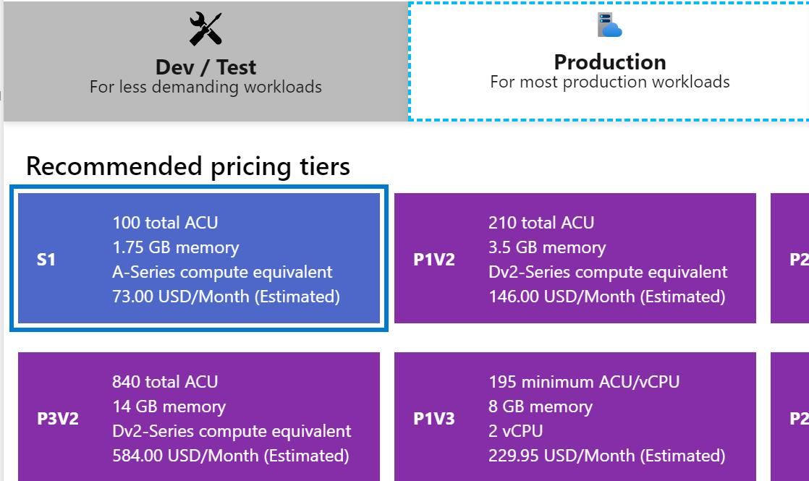

* + Select **Monitoring**, and then in Enable Application Insights, select **No**.
  + Select **Review + create**, review the configuration, and then select **Create**.

You use an Azure [App Service](https://docs.microsoft.com/en-us/azure/app-service/overview) web app to host your website in the cloud in a fully managed environment. An [App Service plan](https://docs.microsoft.com/en-us/azure/app-service/overview-hosting-plans) defines the capacity and scalability of the web servers that support your website.

* In a new browser tab, go to the URL for the new web app at https://wa26430177.azurewebsites.net to verify that it is up and running.

You should see the default Azure App Service home page.

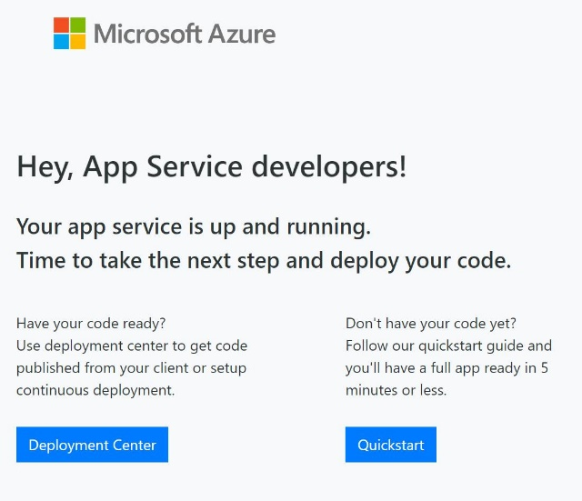

* Enable **Application Insights** for the wa26430177 web app in the **laws-26430177 [eastus]** log analytics workspace.

Expand this hint for guidance on enabling Application Insights.

* + On the Azure portal home page, select **All resources**, and then select the **wa26430177** web app.
  + On the wa26430177 resource menu, in Settings, select **Application Insights**.

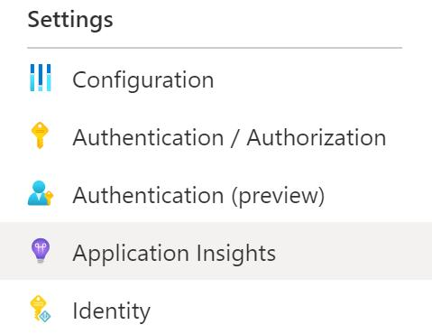

* + On the Application Insights page, select **Turn on Application Insights**.

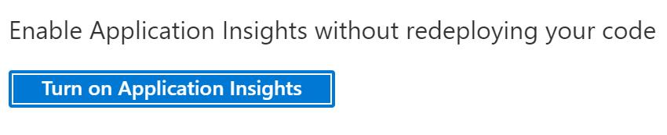

* + In New resource name, ensure that the value is set to wa26430177.
  + In Log Analytics Workspace, select **laws-26430177 [eastus]** and then select **Apply**.
  + If prompted to Apply monitoring settings, select **Yes**.

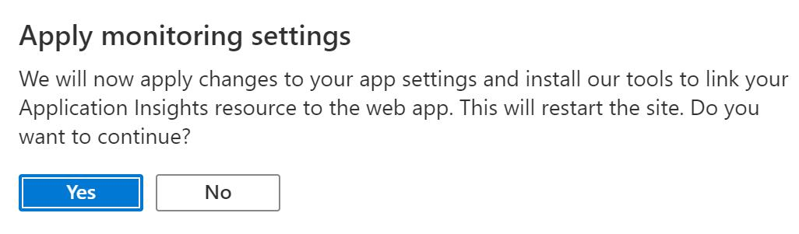

## Check your work

* Confirm that you created a web app named wa26430177.
* Confirm that you displayed the new web app in a browser.
* Confirm that you enabled Application Insights.

# **Deploy sample application code**

* Deploy sample source code for the **wa26430177** web app by using the values in the following table. For any property that is not specified, use the default value.

| **Property** | **Value** |
| --- | --- |
| Source | **External Git** |
| Repository | https://github.com/LODSContent/LODSOC\_app-service-web-dotnet-get-started |
| Branch | main |
| Repository Type | **Public** |

* Expand this hint for guidance on deploying sample source code for a web app.
  + On the wa26430177 resource menu, in Deployment, select **Deployment Center**.
  + On the Deployment Center page, select **Settings**.
  + In Source, select **External Git**, in Repository, enter https://github.com/LODSContent/LODSOC\_app-service-web-dotnet-get-started, in Branch, enter main, and then in Repository Type, ensure that **Public** is selected.

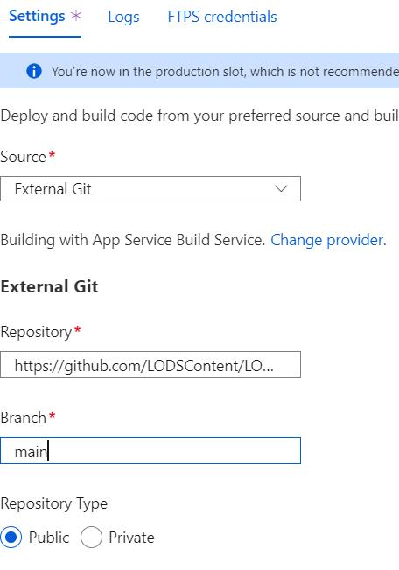

* + On the command bar, select **Save** to initiate the deployment.
  + On the Deployment Center page, select **Logs**, and then periodically select **Refresh** until the deployment appears and the Status changes to **Success (Active)**.

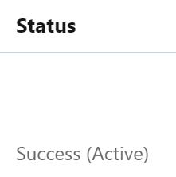

* Verify that you can access the deployed web app in a browser by using an anonymous connection.

Expand this hint for guidance on testing a web app.

You should see the default ASP.NET home page without having to authenticate.

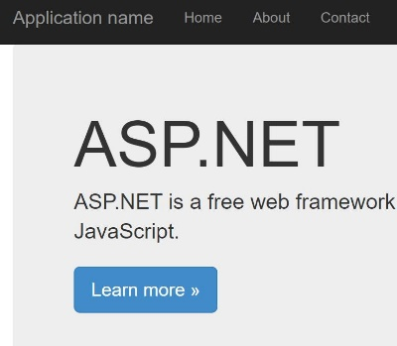

There are many deployment options for an Azure App Service web app. When you plan your deployment, make sure that you review the Azure App Service [deployment best practices](https://docs.microsoft.com/en-us/azure/app-service/deploy-best-practices" \o "Deployment Best Practices" \t "_blank) as part of your planning process.

## Check your work

* Confirm that you deployed sample source code for the wa26430177 web app.
* Confirm that you tested the wa26430177 web app.

# **Enable authentication by using Azure Active Directory**

* Configure Azure Active Directory for the web app by using **Microsoft** as the identity provider.

Expand this hint for guidance on enabling App Service authentication.

* + On the wa26430177 resource menu, in Settings, select **Authentication**, and then select **Add identity provider**. -In Identity provider, select **Microsoft**, and then select **Add**.

You can configure Azure App Service authentication to define your application authentication requirements by using Azure Active Directory as your authentication provider.

* Verify that the app has been registered in Azure Active Directory.

Expand this hint for guidance on verifying app registration in Azure Active Directory.

* + On the Azure portal menu, select **Azure Active Directory**.
  + On the cloudslice resource menu, in Manage, select **App registrations**.
  + On the App registrations page, in Owned applications, verify that wa26430177 is listed.

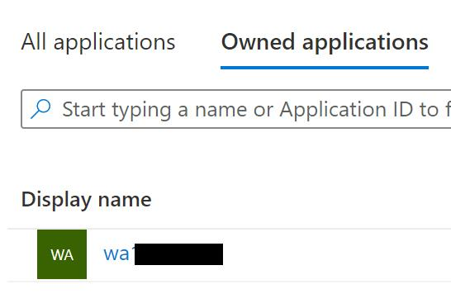

* In a new InPrivate or incognito browser window, go to the URL for the web app at https://wa26430177.azurewebsites.net, and then sign in.
* Accept the permissions requested to confirm first-time authentication to the web app.

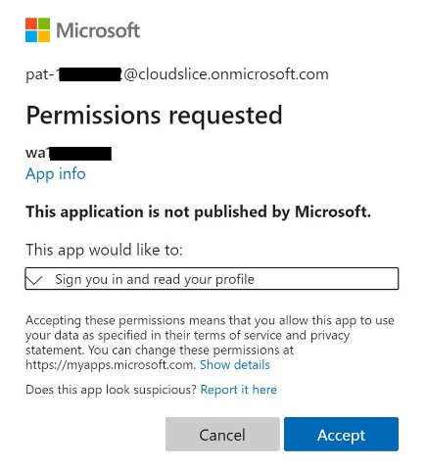

You should see the default ASP.NET home page after authentication is complete.

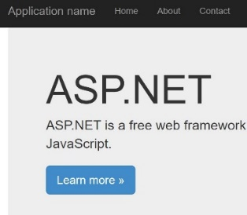

## Check your work

* Confirm that you enabled App Service authentication by using Azure Active Directory.
* Confirm that you registered wa26430177 in Azure Active Directory.
* Confirm that you verified App Service authentication by signing in.

# **Summary**

Congratulations, you have completed the **Configure Authentication for an Azure Web App** challenge.

You have accomplished the following:

* Created an Azure web app.
* Deployed sample application code.
* Enabled authentication by using Azure Active Directory.